**SQL Server Advanced 9**

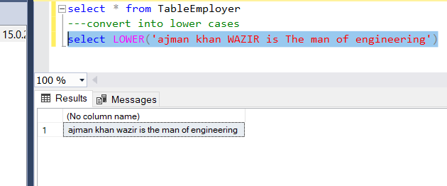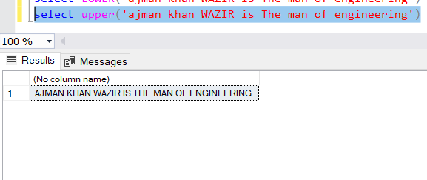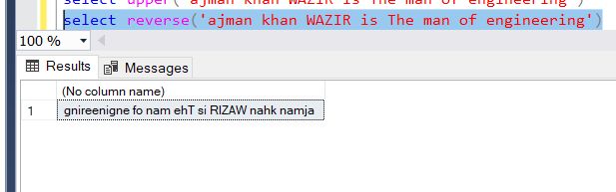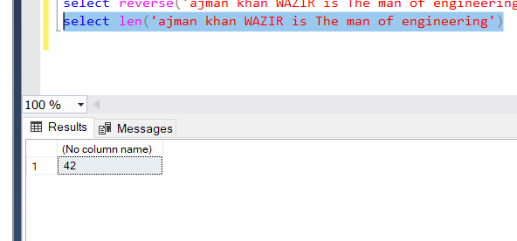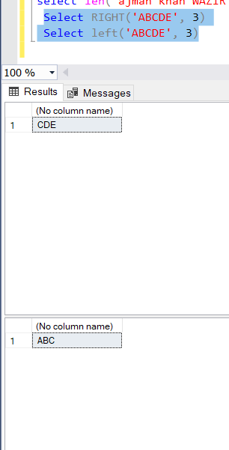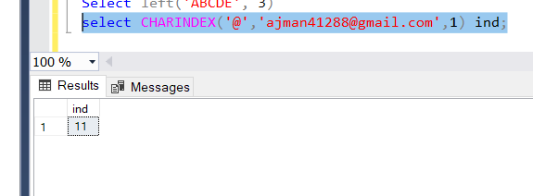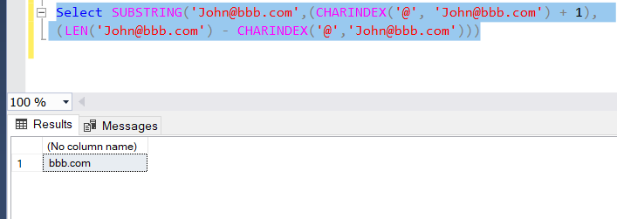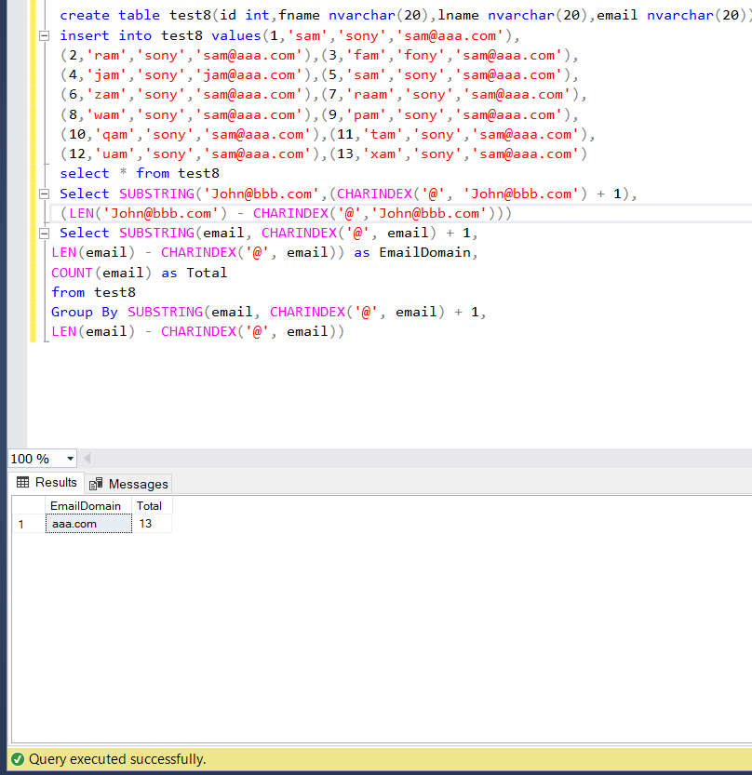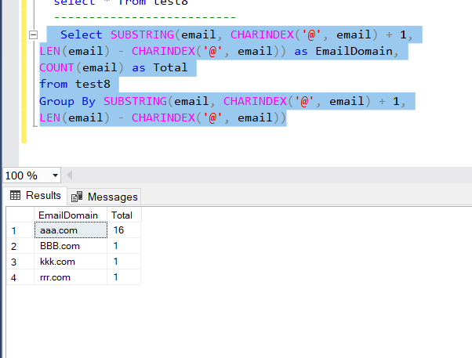

select * from TableEmployer

---convert into lower cases

select LOWER('ajman khan WAZIR is The man of engineering')

select upper('ajman khan WAZIR is The man of engineering')

select reverse('ajman khan WAZIR is The man of engineering')

select len('ajman khan WAZIR is The man of engineering')

Select RIGHT('ABCDE', 3)

Select left('ABCDE', 3)

select CHARINDEX('@','ajman41288@gmail.com',1) ind;

select SUBSTRING('ajman41288@gmail.com',6,len('ajman41288@gmail.com'))

Select SUBSTRING('John@bbb.com',(CHARINDEX('@', 'John@bbb.com') + 1),

(LEN('John@bbb.com') - CHARINDEX('@','John@bbb.com')))

--lets create a table

create table test8(id int,fname nvarchar(20),lname nvarchar(20),email nvarchar(20))

insert into test8 values(1,'sam','sony','sam@aaa.com'),

(2,'ram','sony','sam@aaa.com'),(3,'fam','fony','sam@aaa.com'),

(4,'jam','sony','jam@aaa.com'),(5,'sam','sony','sam@aaa.com'),

(6,'zam','sony','sam@aaa.com'),(7,'raam','sony','sam@aaa.com'),

(8,'wam','sony','sam@aaa.com'),(9,'pam','sony','sam@aaa.com'),

(10,'qam','sony','sam@aaa.com'),(11,'tam','sony','sam@aaa.com'),

(12,'uam','sony','sam@aaa.com'),(13,'xam','sony','sam@aaa.com')

select * from test8

Select SUBSTRING('John@bbb.com',(CHARINDEX('@', 'John@bbb.com') + 1),

(LEN('John@bbb.com') - CHARINDEX('@','John@bbb.com')))

--------------------------------------------------------

Select SUBSTRING(email, CHARINDEX('@', email) + 1,

LEN(email) - CHARINDEX('@', email)) as EmailDomain,

COUNT(email) as Total

from test8

Group By SUBSTRING(email, CHARINDEX('@', email) + 1,

LEN(email) - CHARINDEX('@', email))

--------------------------

insert into test8 values(13,'paream','sony','bam@aaa.com'),

(14,'eeam','sony','bam@aaa.com'),

(15,'iopam','sony','bam@aaa.com')

select * from test8

-------------------------------

Select SUBSTRING(email, CHARINDEX('@', email) + 1,

LEN(email) - CHARINDEX('@', email)) as EmailDomain,

COUNT(email) as Total

from test8

Group By SUBSTRING(email, CHARINDEX('@', email) + 1,

LEN(email) - CHARINDEX('@', email))

----------------------------------------------

insert into test8 values(16,'paream2','sony','bam@kkk.com'),

(17,'eeam2','sony','bam@rrr.com'),

(18,'iopam2','sony','bam@BBB.com')

------------------------------------------------------------

select * from test8

--------------------------

Select SUBSTRING(email, CHARINDEX('@', email) + 1,

LEN(email) - CHARINDEX('@', email)) as EmailDomain,

COUNT(email) as Total

from test8

Group By SUBSTRING(email, CHARINDEX('@', email) + 1,

LEN(email) - CHARINDEX('@', email))

----------------------------------------

**SQL server Triggers:**

There are three types o triggers mainly

1. DML Triggers
2. DDL Triggers
3. Logon Triggers

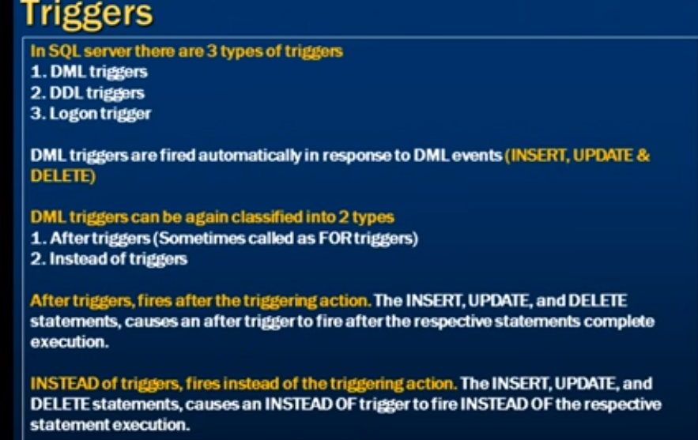

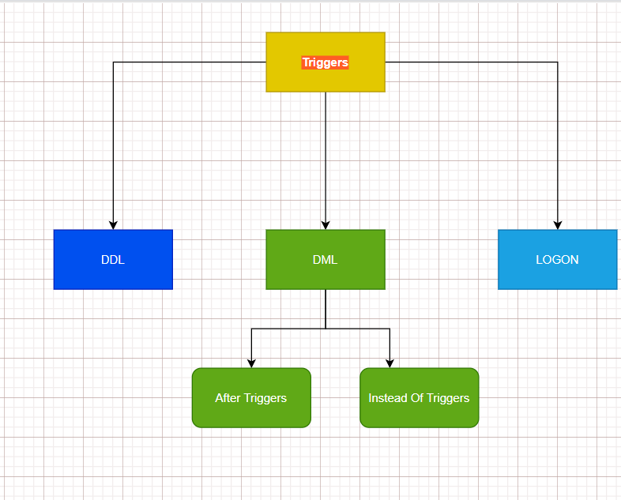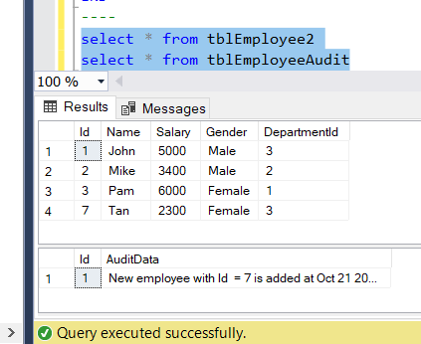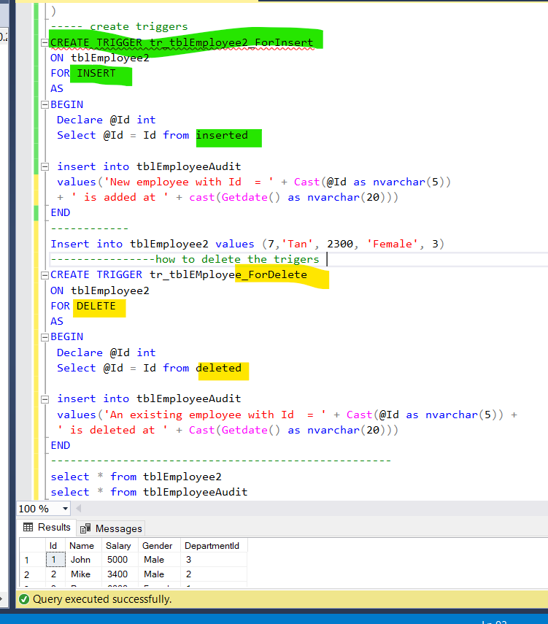

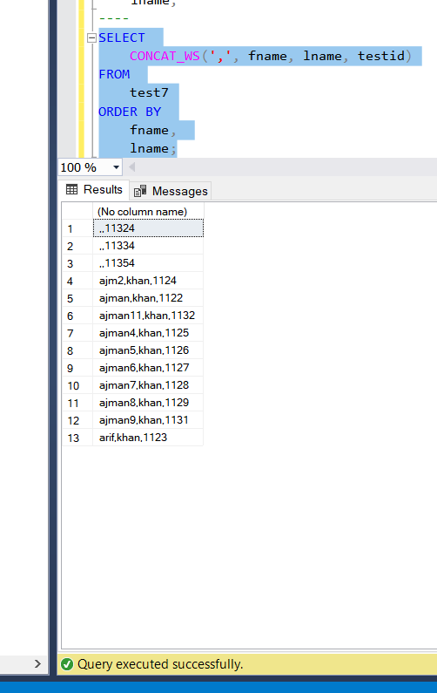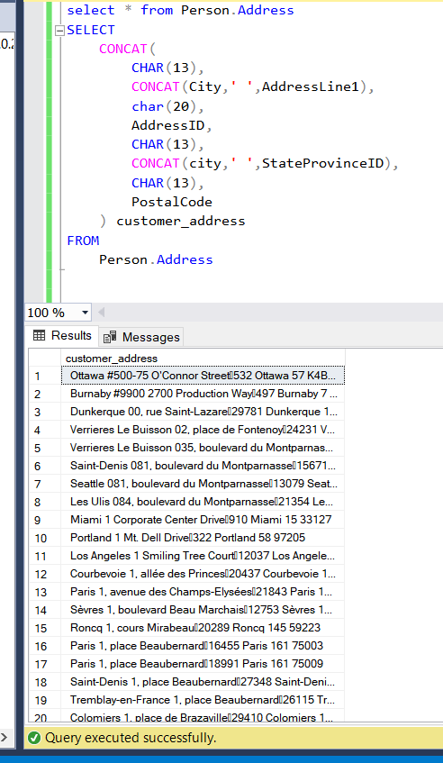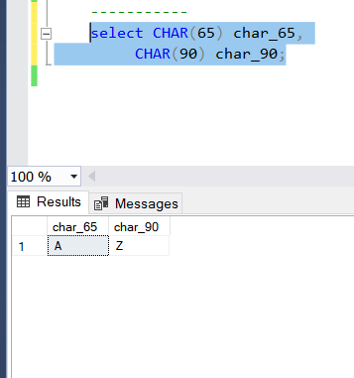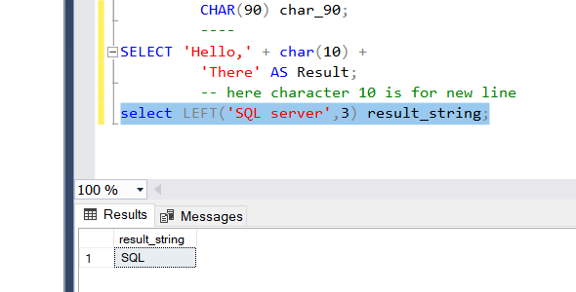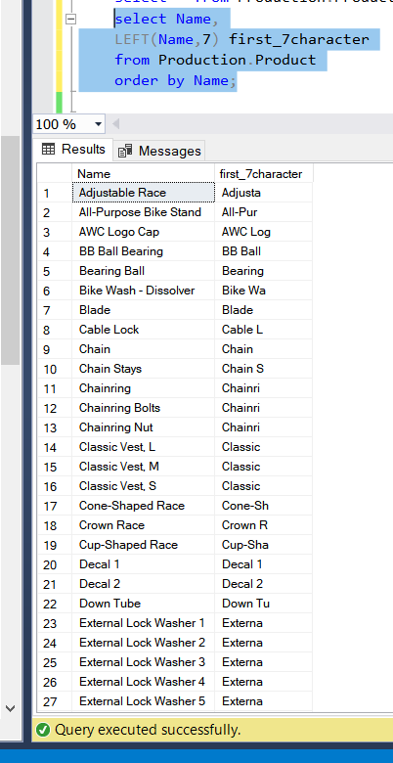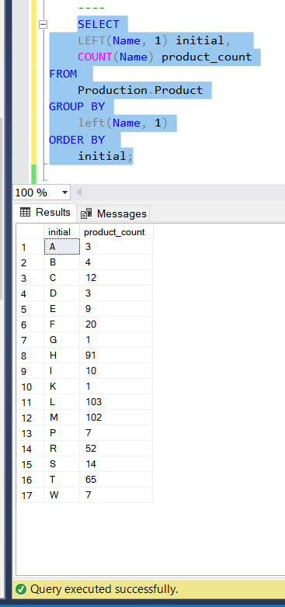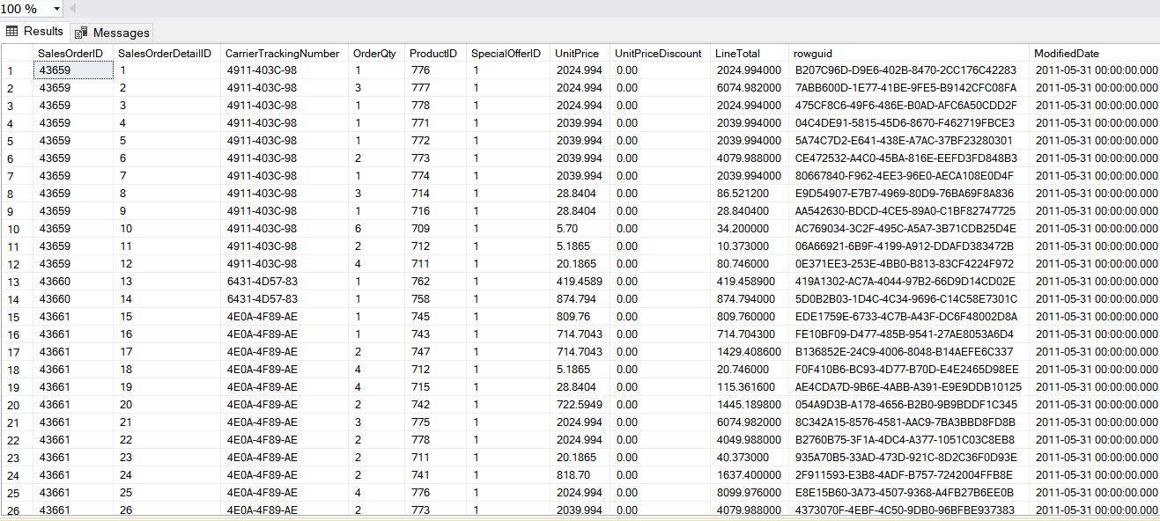

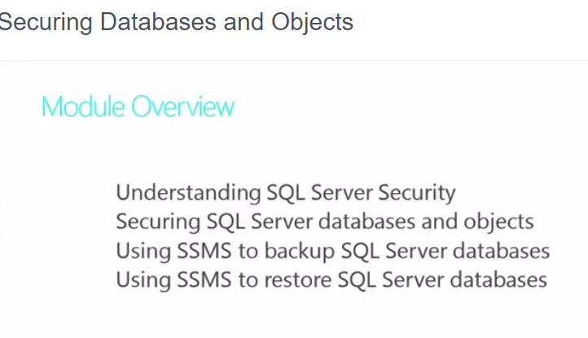

**MS ACCESS:**

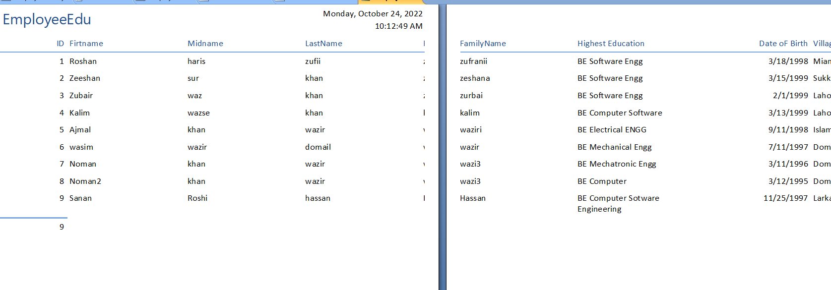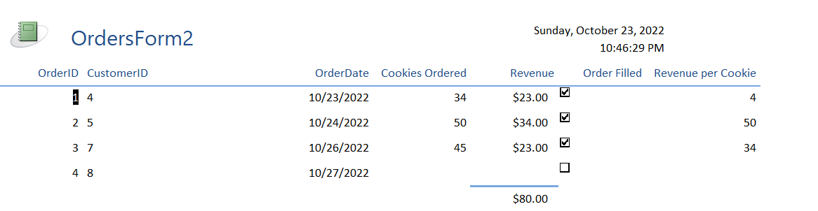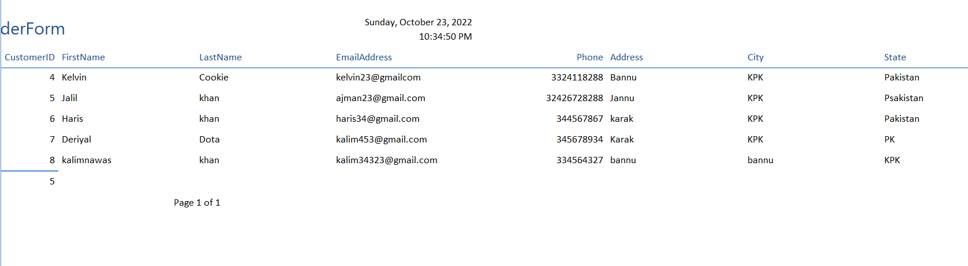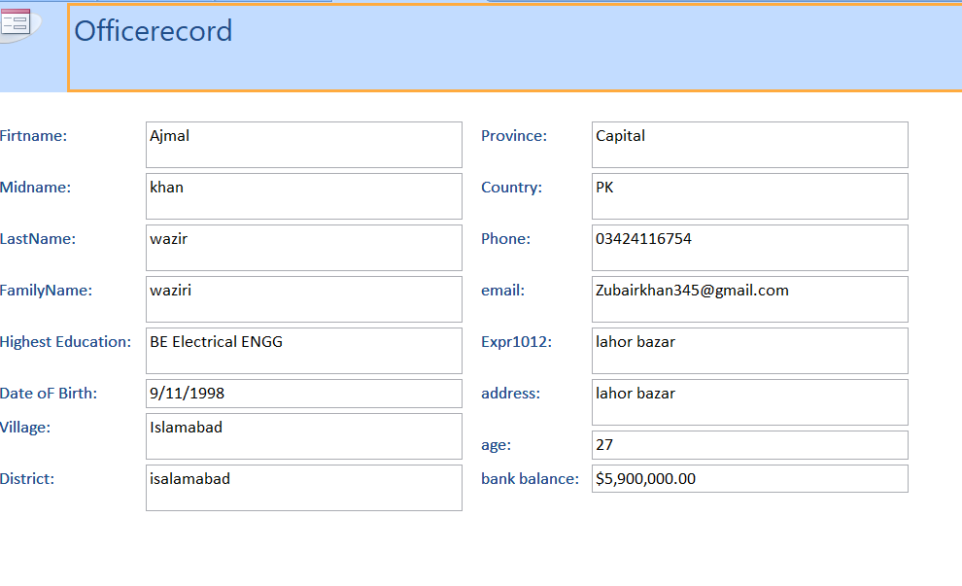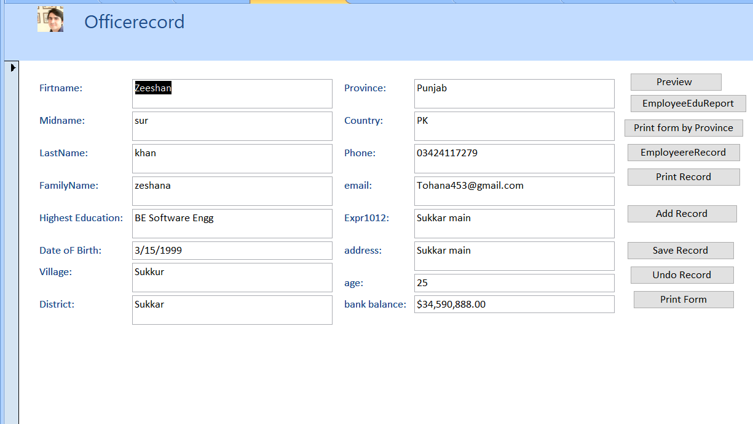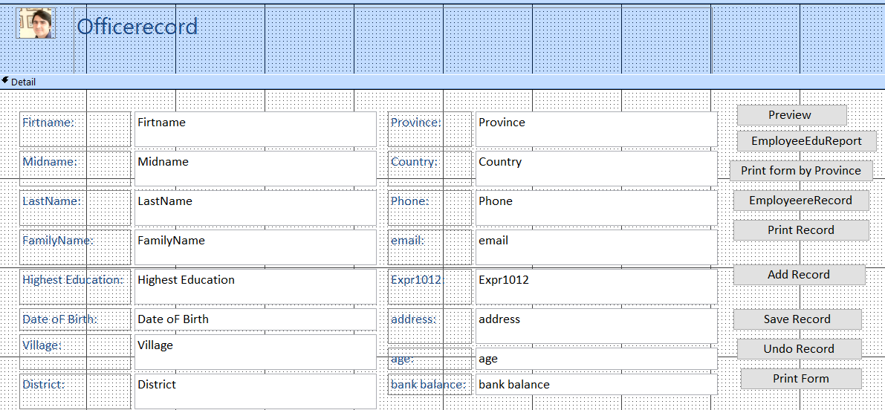

****2)**** If you want to see the code behind this macro right click.

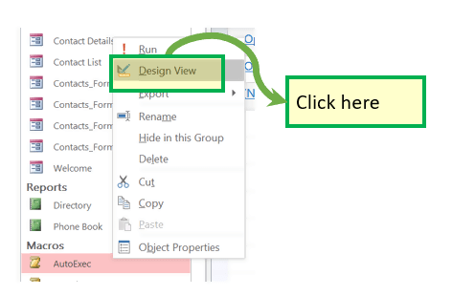

****Result:****

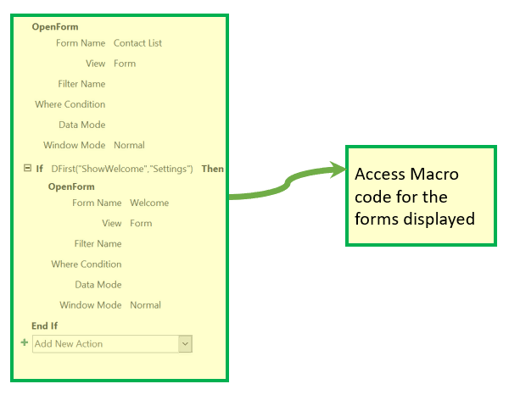

## **Module**

* It is a collection of user-defined functions, declarations, statements, and procedures that are stored together as a unit.
* It perhaps a standalone object having functions that you can call from anywhere in your Access database.

****MS Access databases example from ‘Contact’ DB****

****Step 1)**** Click on ‘modMapping’

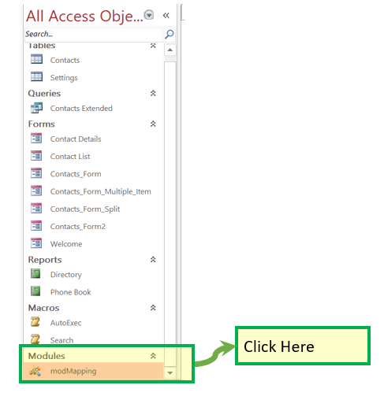

****Result:****

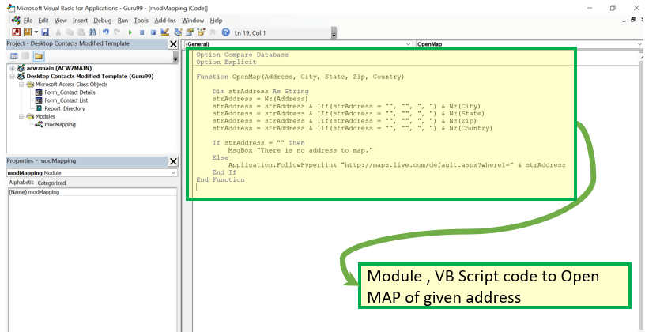

## **Summary**

* Microsoft Access is a [Database Management System](https://www.guru99.com/what-is-dbms.html) offered by Microsoft.
* Allows you to create tables, queries, forms, and reports, and connect with the help of Macros
* MS-Access will enable you to link to data in its existing location and use it for viewing, updating, querying, and reporting.
* Access consists of ****four main database objects****: Tables, Queries, Forms, and Reports.
* There are ****two ways****to****create Database in SQL Access****:
* Create Database from****Template****
* Create a ****Blank Database****
* There are ****two ways****to****create Database in MS Access****
* Create a Table from ****Design View****
* Create a Table from ****Datasheet View****
* You can switch between the datasheet and the design view by just clicking the ‘View’ button in the top-left hand corner of the Access program.
* A form can be created using Form Wizard, Form, Multiple Item, Split Form
* Macro in MS Access database is a time-saving feature that allows you to add functionality or automate simple tasks.
* A report is an object in MS Access that is designed for formatting, calculating and printing selected data in an organized way.
* A Module is a collection of user-defined functions, declarations, statements, and procedures that are stored together as a unit.

**Important Links:**

**<https://www.guru99.com/ms-access-tutorial.html>**

